Name ________________________
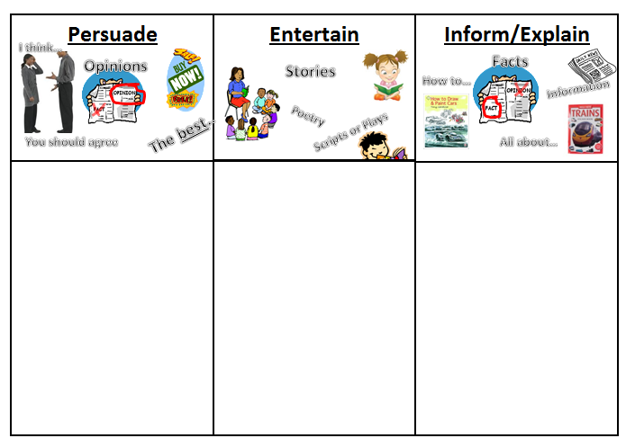
AUTHOR’S PURPOSE
Highlight the text, cut (control + x) and paste (control + v) above:
Steven ran quickly down the hill and jumped into the mud puddle. | Trees in bloom  Bees zoom  As I look out of my room | Spiders are scary because they can bite.
Pizza tastes better than hamburgers. | Sarah and her sister started to argue. “It’s mine!” Sarah said. | After drilling the hole, place the board on the table.
This is a very nice place to live. | Cars and Trucks Stranded  On Saturday night the ice caused a traffic jam on the freeway. | Arctic foxes can live in dens under the snow. They also often make their dens under logs.

